

**NATIONAL CERTIFICATE**

# STRENGTH OF MATERIALS AND STRUCTURES N5

(8060065)

**23 April 2021 (X-paper)**

**09:00–12:00**

**This question paper consists of 6 pages and a formula sheet of 2 pages.**

317Q1A2123



Copyright reserved Please turn over

## DEPARTMENT OF HIGHER EDUCATION AND TRAINING

**REPUBLIC OF SOUTH AFRICA**

NATIONAL CERTIFICATE

STRENGTH OF MATERIALS AND STRUCTURES N5

TIME: 3 HOURS

MARKS: 100

### INSTRUCTIONS AND INFORMATION

1. Answer all the questions.

1. Read all the questions carefully.

1. Number the answers according to the numbering system used in this question paper.

1. Start each question on a new page.

1. Write neatly and legibly.

### QUESTION 1

A round steel rod subjected to a tensile load of 70 kN is represented in FIGURE 1. Young's modulus is 190 GPa.

Note: All dimensions in FIGURE 1 are in mm.

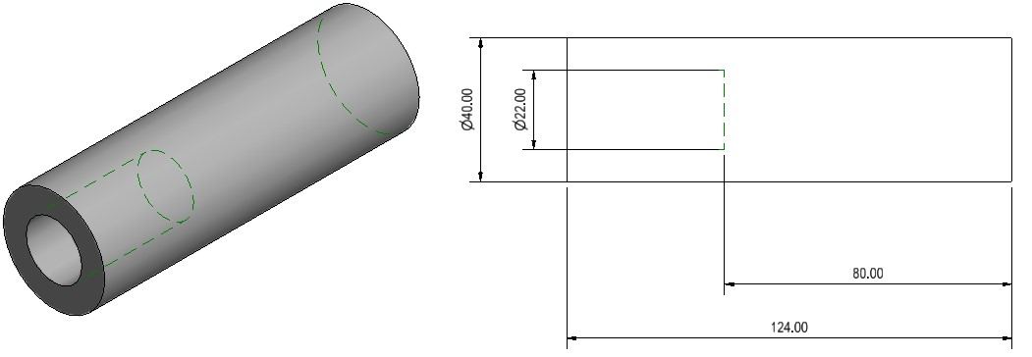

**FIGURE 1**

Calculate the following:

1.1 The maximum stress in the rod (4)

1.2 The minimum stress in the rod (3)

 

1.3 The total strain in the rod (7)

1.4 The change in length of the hollow section (4)

1.5 The strain energy in the hollow section if gradually loaded (4)

**[22]**

### QUESTION 2

|  |  |
| --- | --- |
| A weight of 300 kN is supported by a short reinforced concrete column. FIGURE 2 shows a cylindrical concrete column of 150 mm in diameter reinforced with three steel bars, each 15 mm in diameter. Young's modulus for steel is 210 GPa and 18 GPa for concrete. |  |

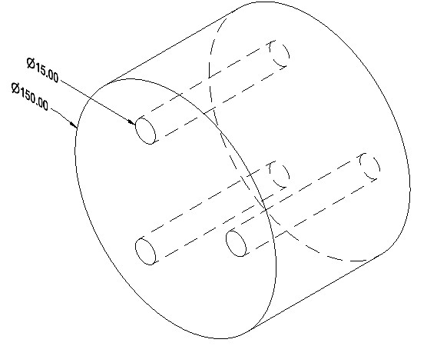 

**FIGURE 2**

Calculate the following:

2.1 The stress in the concrete and steel. (14)

2.2 The area of the total reinforced steel if a load of 800 kN is applied and the

stress in the concrete does not exceed 6,23 MPa.  (8)



2.3 The modular ratio for the concrete and steel. (3)

|  |  |  |
| --- | --- | --- |
| **QUESTION 3** |  | **[25]** |
| The internal diameter of a cylindrical pressure vessel is 3,2 m and is limited to internal pressure of 4 MPa. The tensile stress in the material is 120 MPa and the longitudinal |  |  |
|  |  |  |

efficiency is 75%.

Calculate the thickness of the cylinder plate needed for the pressure vessel.  **[4] QUESTION 4**

Refer to the shear force diagram in FIGURE 3 to answer the questions.

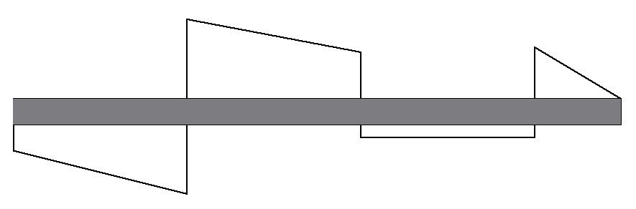

A



E



D



C



B



-

kN

110



kN

92



kN

54



-

45

kN



kN

60



-

60

kN

**FIGURE 3**

4.1 Draw the force (configuration) diagram.  (8)

|  |  |
| --- | --- |
| 4.2 Calculate the maximum bending moment. | (5) |
| **QUESTION 5** | **[13]** |
| FIGURE 4 represents a strut with a length of 12 m built in at both ends. The strut consists of an I-section of 178 × 102 and two flat steel plates of 100 mm × 6 mm.    The strut is subjected to a load of 110 kN and has an allowable stress of 125 MPa. |  |

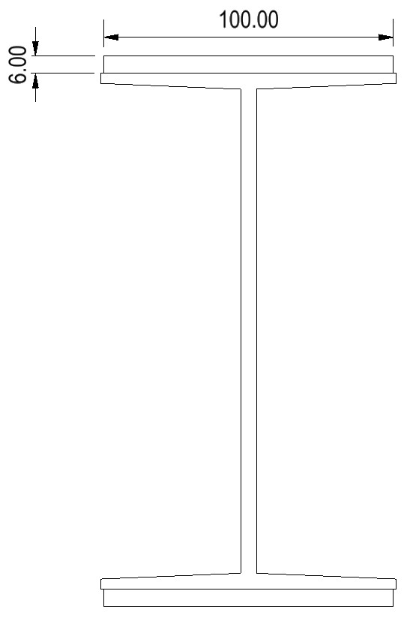

|  |  |  |
| --- | --- | --- |
|  |  |  |
| **FIGURE 4** |  |  |
| Calculate the value of the Rankine's constant. |  | **[19]** |

### QUESTION 6

|  |  |  |
| --- | --- | --- |
| Calculate the maximum torque that can be transmitted by a shaft with a diameter of 63 mm and a length of 600 mm. The shear stress in the shaft must not exceed | | **[10]** |
| 55 MPa and the angle of twist must not exceed 1°.    The modulus of rigidity is 70 GPa.    Substantiate your answer.      **QUESTION 7**    7.1 Name the TWO main methods used to protect steel against corrosion or to |  |

minimise corrosion. (2)

7.2 List FIVE main methods of protective coating that may be applied to steel to

prevent corrosion. (5)

### [7]

**TOTAL:**  **100**

 Please turn over

-1-

### STRENGTH OF MATERIALS AND STRUCTURES N5

Any applicable equation or formula may be used.

*F*



*A*

*X*



*L*

*FL*

*E*  *Ax*

 1 1 

*F* *A*1*E*  *A*2*E**t*(2 1)

*F* *AL*11*E*  *AL*22*E* *L*11*t*  *L*22*t*

*U* *Fx*

*F*2*L*

*U* 

*ac*

*b*

*b*

4

2

−



−

2*AE*

*x* 

2*a*

*F*2*L mg*(*h* ) 

2*AE*

*T*  *G*  

*J r L*

(*D*4  *d*4)

*J*  32

❐ (*D*4  *d*4)

*T*   16 *D*

*T* *D*3

16

10,2 *TL*

 4

*GD*

10,2 *TL*

 *G*(*D*4  *d*4)

*P* 2*NT*

*M*  *E*  

*I Y R*

*WL*

*M*  8

*L*2

*M* 

8

*WL*

*M* 

4

*I*

*Z*  *y*

*M* *Z*

*I*  (*D*4  *d*4) 64

*I*  *D*4

64

*bd*3

*Ixx* 

12

2*EI*

❐ *F*  2

### *Le*

*F*  *A* 2

1  *a* *Le* 

 *k* 

42*EI*

*F*  2

*L*

*F* 

2

4

1















*k*

*L*

*a*

*A*

⬧

*A*

*I*

*k* 

*S* .*v*  *Le* ; *S* . *R*  *Le* *k k*

Hinged ends *Le*  *L* *L* Fixed ends *Le* 

2

*L*

One end fixed, one end hinged *Le* 

2

Please turn over

-2-

One end fixed, one end free *Le* 2*L*

*PD*



2 . *t*

*PD*



4 *t*

(*p*  *d*) *t**t* 100



*pt**t*

*d*2 *n*

100 *pt**t ndt**c* 100

4



*pt**t* *d*2

*t*(*p*  *d*) *t*   *nt*

4

(*p*  *d*) *t**t*  *dtn**c*